Burpee and Mills Newsletter September 2023

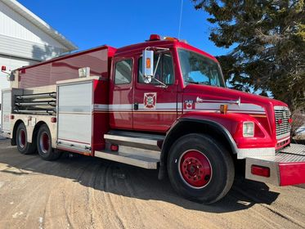
Burpee and Mills Fire Department welcomes four new volunteers to the team! The strength of the department lies in its volunteers and it's good to see new people show interest and join the team. The township thanks them, as well as the continuing efforts of all our volunteers. Your service is greatly appreciated!!
Fire practice will continue to be the second and fourth Tuesday of every month.
After a summer off, the startup of euchre will be postponed until October 2, 2023. Monday night at the township complex will be the place to be again.

Kids have returned to school this week. Keep a sharp eye on the roads for the school buses again. It will take some time for the kids to get back into the routine of safely getting on and off the bus. Be sure to watch for the lights and stop in both directions.

Recreation and Wellness Committee. There is a committee meeting September the 11th at 7:00pm at the Township complex.

GG's Diner is bringing back the Angel Bus cookie fundraiser. September's cookie will be oatmeal raisin. They will be closed Sept 4 - 6 to give their staff a well-deserved break after a very busy, and successful summer. GG's passes along their thanks to all the many patrons from Burpee and Mills for their ongoing support this summer, and for the entire year.
The hours will change on September 7th. Closing time will be 7:00pm for the fall and winter, until further advised.

Notes from Council. The next regular council meeting will be Tuesday October 3rd at 7:00pm.

The waste Transfer Station has reverted to fall/winter hours. It is no longer open on Tuesday afternoons. Regular hours are Thursday 7:00-8:00pm. and Saturday 10:30am-12:00pm.
Please continue to thoroughly sort your recyclables!! The more waste we can divert from the landfill, the better.

The Gym will continue to be open during regular office hours as well as Tuesday and Thursday night from 7:00pm-9:00pm.
A strong immune system is the best defense against any illness. It's never too late to start a program to build the strength of both your heart and muscular system. Small amounts of effort can have big returns.
We have a great gym with fantastic volunteers. All are welcome to come and use it at very reasonable prices.

Fire Prevention. With the wetter weather of fall rapidly upon us, it's no time to let your guard down and be careless. There is still a fire ban for everything except campfires. Caution is still to be exercised, as well as close monitoring of any fire.
It's also time to start thinking about cleaning your chimney. It won't be long before the evenings are cool enough for a fire. Make sure your stove and chimney are cleaned, and in good working order, before you have that first fire.

