Burpee and Mills Newsletter August 2023

*WE ARE CURRENTLY EXPERIENCING ISSUES WITH OUR ETRANSFERS. PLEASE DO NOT E-TRANSFER TAX PAYMENTS UNTIL FURTHER NOTICE.*
Taxes are due August 31ST.
They can be paid by cash or cheque or Bank Draft. Office hours are Monday to Thursday 8:30 – 4:00 (Closed from 12 to 12:30 daily)

The Fire Ban Remains in Effect!!

Burpee and Mills Fire Department:
They continue to practice the second and fourth Tuesday of the month.

Movie Night at Prior Point Theatre
Wednesday nights at 7:30pm. 16712 Hwy 540, hosted by Tom and Becky Prior.
Here are the coming attractions!
August 2nd Frozen 2 August 9th Avatar: The Way of Water August 16th Top Gun: Maverick August 23rd Elvis August 30th The Lost City September 6th She Said

GG'S Diner
GG”s is now open 6 days of the week. Closed Wednesdays.
Hours are now 12:00pm-8:30pm. The dart alley is now open as well and ready to go!!

Notes from Council
The next regular council meeting is Wednesday September 6th.

The Gym
Our fitness centre remains open during normal business hours and Tuesday and Thursday evenings from 7:00pm - 9:00pm. Weight training at any age has enormous benefits to all aspects of your health. You don't need to be a bodybuilder to reap huge benefits. Even lifting lighter weights has enormous benefits in weight loss, cardiovascular health, as well as overall immune system function.

The waste transfer station
The transfer station continues to operate under summer hours. Tuesday 2:00pm - 3:00pm. Thursday 7:00pm - 8:00pm. And Saturday 10:30am - 12:00pm.
Please continue to recycle as it takes a lot of pressure off what we send to the landfill and saves us all money in the end.

The Burpee and Mills welcome sign is now relocated on Highway 540.

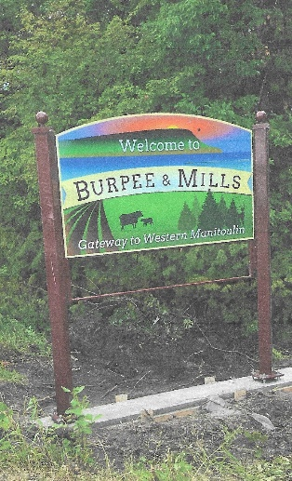

You don’t need to know the whole alphabet of Safety. The A, B, C of it will save you if you follow it: Always Be Careful. With the long weekend upon us, the temptation to let off a few fireworks will be strong. Nobody is trying to ruin your fun, but with the continued fire ban, fireworks are not allowed.

