Burpee Mills Newsletter May 2023
Burpee and Mills Fire Department held an Easter Egg Hunt that was a tremendous success. Eggs kept popping up all over the township, all weekend long. The winners were;
In first place was the Kamenicky Family with 51 reg eggs, 9 sparkle for a total of 60.
In second place was Ejay Gilmore and Family with 54 reg eggs, 1 sparkle for a total of 55 eggs.
In third place was the Desaulniers Family with 51 reg eggs, 3 sparkle for a total of 54 eggs.
The most sparkle eggs prize went to Regan Milsap and Christie Middleton with 10 sparkle eggs. Special prize given to Hayden McMillan with 12 eggs. Egg hunters who also had fun participating were Mike Honess Family, 22 eggs. Nick, MaryJo and Danny Harper with 31 eggs. Jordyn Canning and Cindy Middleton with 34 eggs. Curtis Pfeifer Family, 13 eggs.
Special thank you to everyone who hunted and had fun and to Lucas Wright and Jesse Middleton for volunteering to help Rick and Nikki hide eggs.
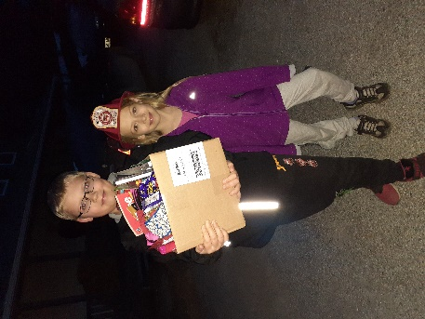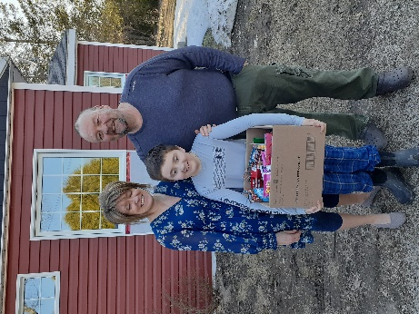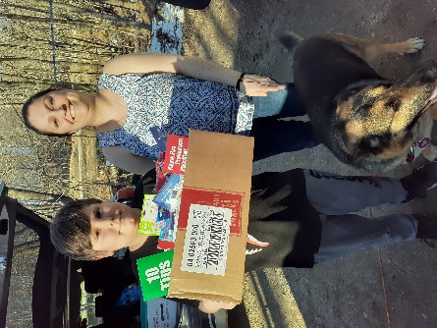

Fire Fighter Practice is the second and fourth Tuesday of every month.
Congratulations To Nicole Middleton. Nikki was recognized for all her volunteer work in the April 19th Expositor. The list of projects she has been involved with is extensive. The article is really well written and well worth a read. It will give a real appreciation of how much Nikki does for the people of this community, and how fortunate we are that there are people like her, that give so much of their time, to make life better for others. The recognition to Nikki was well deserved and long overdue.
The Transfer Station goes to the summer schedule June 6th. It will be open on Tuesdays from 2-3pm, in addition to its current hours. We no longer take glass for recycling. Remember to sort steel food cans from aluminum pop cans and all must be clean. Our station does not take electronics, construction materials, mattresses, or bed frames.
​Join us Monday nights at 7:00pm for euchre!! $5 to play. All are welcome. It will continue until the end of June, then go on hiatus for the summer.
GG's Diner -- don't forget the monthly cookie to support the Angel Bus. Enjoy a tasty treat while supporting a good cause!!
Starting May 1st GG's will be open Thursday through Monday from 12pm - 7pm. Closed Tuesday and Wednesday only. On the days they are open, they will stay open late to air the NHL Playoffs. Come cheer for your favourite team!! ​
​Thursday night feature will be changing from pizza to wing night.
Saturday May 13th ​ there will be a Mother's Day High Tea. There will be two seatings: 11:00am - 1:00pm or the later one from 1:30pm - 3:30pm. RSVP by May 11th. $45 / person
​Saturday May 27th there will be a Dinner and Dance featuring Beth and Joe from Island Time Dancing. Admission will be $40/person and will cover tea/coffee, buffet dinner, dessert, and entertainment. Reservation required please.​ (705) 282-0244
​The Township of Burpee and Mills has a seasonal employment opportunity. It will involve the maintenance and care of outdoor recreation facilities, including grass cutting and such. Must be between 16 and 30 years old and have a valid G-2 driver’s license. Submit your resume before June 1 st in person to the township office or via email to burpeemills@vianet.ca.
The gym continues to be open during regular business hours, as well as Tuesday and Thursday evening from 7:00pm-9:00pm. Weight training with even light weights, has been proven to improve mental health as well as physical health. The connection between physical and mental health is very real.
There will be a Recreation and Wellness Committee meeting on May 16th at 7:00pm. Please feel free to come and attend.
Notes from Council The next council meeting is Tuesday June 6th at 7:00pm. On May 10th there will be a public meeting concerning a proposed amended to the zoning bylaw regarding Concession 6, Pt lots 36 & 37.
If you'd prefer the newsletter emailed to you, please contact Lynn at the township office. Also, if you've had issues not receiving the printed version, let her know so we can rectify the situation.
A gentle reminder that a burn permit is required for burning anywhere in the township. There are two types. One is for a burn barrel and is good for a year. The other is for a brush pile and is good for 7 days. Both are free. You can submit your request through the township website www.burpeemills.com. Burning grass is not permitted in Burpee and Mills Township!!

